**ASG 02**

**Name:** Yatharth Thakare

**Roll No:** 51

**PRN:** 12111403

**Subject:** SI

**Problem Statement :** Define polynomial regression. Implement polynomial regression to capture non-linear relationships between the feature and the target variable.Compare it with linear regression and plot the difference using visualization methods.

**Polynomial Regression:** Polynomial regression is a type of regression analysis used to model the relationship between a dependent variable and one or more independent variables by fitting a polynomial equation to the observed data points.

**Goal:** The objective in polynomial regression is to determine the best-fitting polynomial curve that minimizes the difference between the observed data points and the predicted values generated by the polynomial model.

The polynomial equation takes the form:

Y=β0+β1X+β2X2+β3X3+...+βnXn+ϵ

In polynomial regression, the aim is to find the coefficients β0, β1, β2,...,βn that define the polynomial curve, allowing it to closely approximate the observed data points while minimizing the error term ϵ.

Polynomial regression is particularly useful when the relationship between the variables is curvilinear or when the data cannot be adequately modeled using linear regression. It is commonly used in various fields, including economics, biology, engineering, and physics, where relationships between variables may exhibit nonlinear patterns.

1. Loading the dataset “manufacturing.csv”

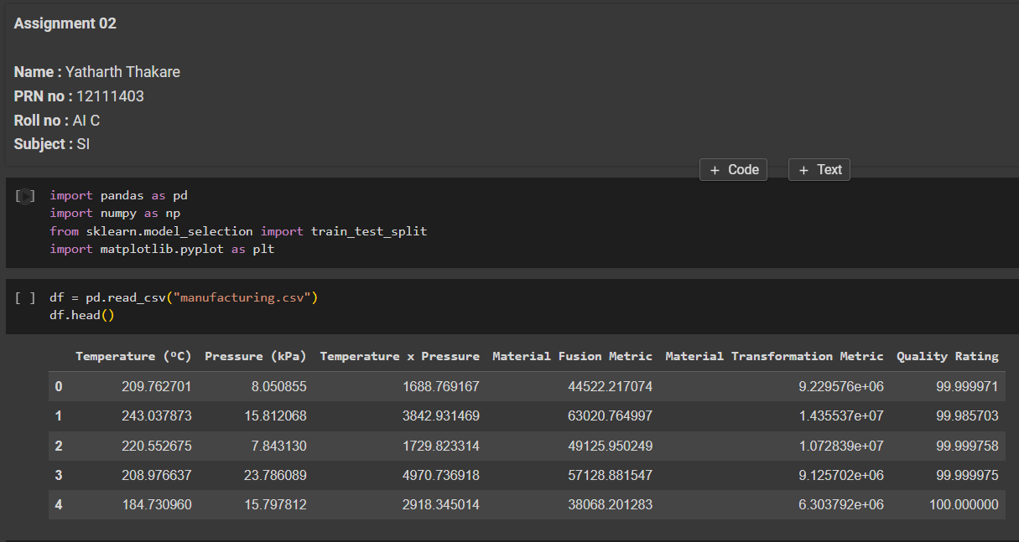

1. Evaluating and splitting the data

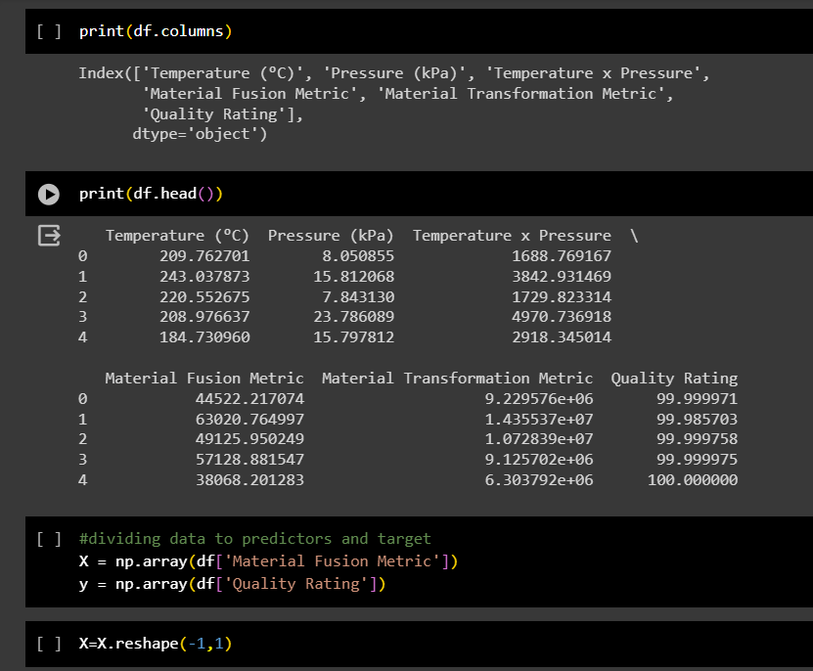

1. Implementing Linear Regression model , Predicting values and calculating error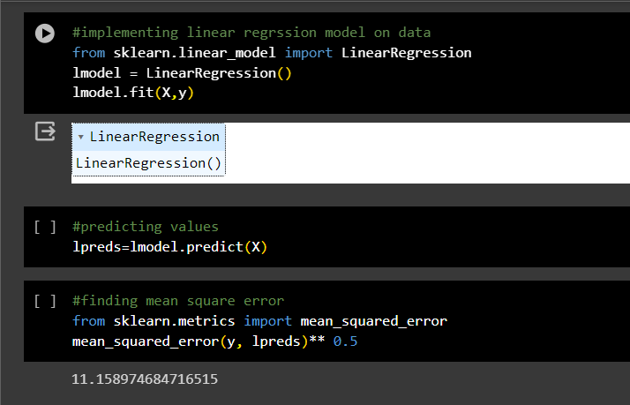
2. Implementing Polynomial Regression model , Predicting values and calculating error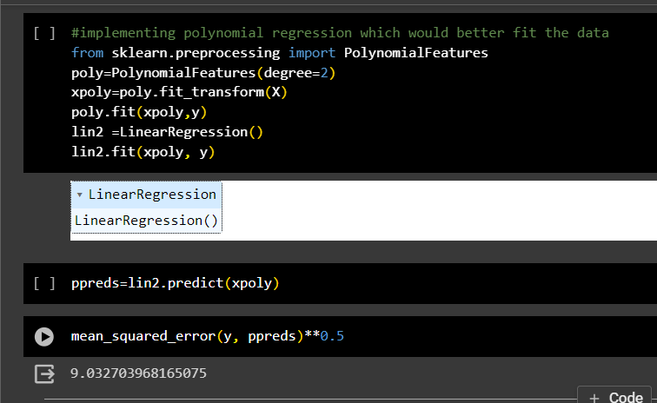
3. Visualizing the results of Linear Regression.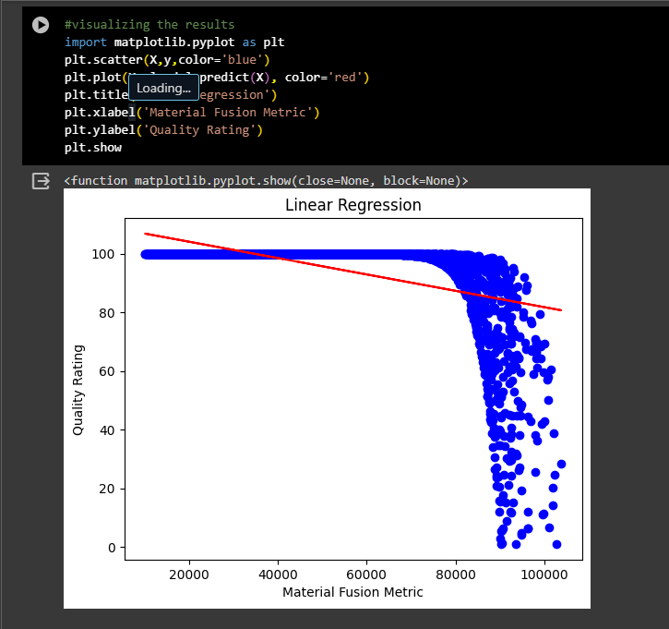6. Visualizing the results of Polynomial Regression.